**Website Planning Document**

Weather Forecast Site

Purpose:

The purpose of this site will be to show relevant data regarding weather conditions. This will be accomplished by taking user input on what area the data will be about. To do this we will:

* Decide what our target audience will be.
* Create a model for several different device sizes
* Create an attractive color scheme
* Use a reliable and useful weather reporting service to gather data for the user

Target Audience personas:

Penny- 21

College Student

Works a part time job while going to school

Primary accesses the site from her smart phone

Jim- 46

Travelling sales consultant

Married with 3 children

Primarily checks the weather on his laptop when he is in other cities.

Terry- 33

Doctor

Single

Uses the site to check the weather for her morning commute.

James-19

College Student

Single

Travels long distance to get to school checks site before he leaves.

Shannon- 35

Mom

Married with 2 kids

Checks the weather in the morning and several days in advance to make daily plans.

Site Map:

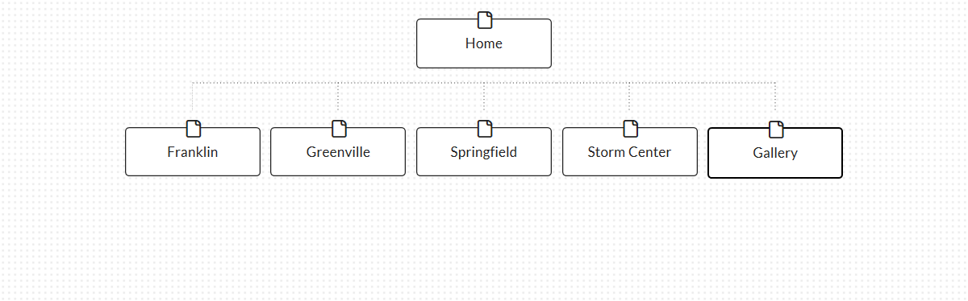

Color Scheme:

Background: rgb(51, 153, 102)

Content Boxes: rgb(0, 102, 255)

Nav: rgb(255, 255, 255)

Footer: rgb(51, 204, 255)

Typography:

Site header: Tahoma

Nav: Tahoma

Heading 1: Tahoma

Heading 2: Tahoma

Heading 3: Tahoma

Paragraph: Perpetua